veepooSDK access documentation

Secret level: for partner use only
Edit: Li Jinliang
Time: 2017-03-23

Access process description 2
1. reference lib 3
2. Configure Androidmanifest.xml 4
1. Permission configuration 4
2. Software and hardware characteristics requirements 4
3.Activity&Service configuration 4
3. make a Bluetooth communication connection 5
1. Operating instructions 5
2. Scan for Bluetooth devices 6
3. Connect a Bluetooth device 6
4. Set the connection status monitoring of the connected device 6
5. Set the system Bluetooth status monitoring 6
4. Bluetooth data interaction 7
1. Bluetooth log description 7
2. Bluetooth data delivery 8
3. Bluetooth data return 9
5. firmware upgrade 10
1. AndroidMainfest.xml configuration 10
2. Judgment before upgrading 10
3. Call the official upgrade program 11
6. other instructions 11

Access process description

Because Android only supports BLE 4.0 as long as the system is 4.3 or higher, the minimum API version required when creating a project is 19.

To know the SDK call as soon as possible, you can run the provided VpBluetoothSDKDemo project

The specific operation sequence is to import the Jar package ---> configure AndroidMainfexst.xml-> call the SDK.

For details on how to call the SDK, please see index.html under the ApiDoc file.

When viewing the api, you only need to start from the VPOperateManager class.
VPOperateManager under com.veepoo.protocol

1. reference lib

Reference the following three libs in the app

1.gson-2.2.4.jar
2.vpbluetooth_x.x.x.jar
3.vpprotocol_x.x.x.jar

As shown in the figure:

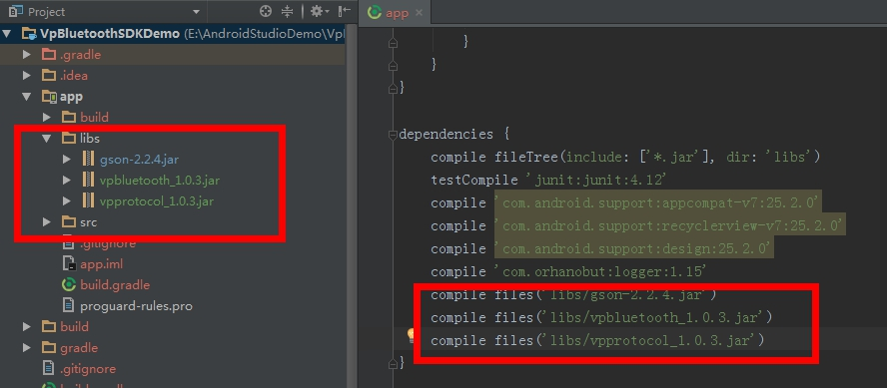

Reference succeeded for next step

2. Configure Androidmanifest.xml

1. Permission configuration
Contains Bluetooth, location information, network, read and write permissions on external storage files.
On some Andorid 6.0 phones, only when the location information permission is turned on, can the device be scanned.

<uses-permission android:name="android.permission.BLUETOOTH" />
<uses-permission android:name="android.permission.BLUETOOTH_ADMIN" />
<uses-permission android:name="android.permission.ACCESS_FINE_LOCATION" />
<uses-permission android:name="android.permission.ACCESS_COARSE_LOCATION" />
<uses-permission android:name="android.permission.INTERNET" />
<uses-permission android:name="android.permission.ACCESS_NETWORK_STATE" />
<uses-permission android:name="android.permission.WRITE_EXTERNAL_STORAGE" />

2. Software and hardware characteristics requirements
The hardware must support Bluetooth.
<uses-feature
android:name="android.hardware.bluetooth_le"
android:required="true" />

3.Activity&Service configuration
<!-- Bluetooth service -->
<service android:name="com.inuker.bluetooth.library.BluetoothService" />
<!-- Firmware upgrade function related, please check VpBluetoothSDKDem source code -->
<service android:name=".oad.service.DfuService" />
<activity android:name=".oad.activity.NotificationActivity" />

3. make a Bluetooth communication connection

1. Operating instructions
All operations are only through VPOperateManager;

Get VPOperateManager instance
Note: In order to avoid memory leaks, please use context with caution, it is recommended to use getApplicationContext();

Context context=getApplicationContext()
VPOperateManager.getMangerInstance(context)；

For details on how to call the SDK, please see index.html under the ApiDoc file.

Call scan device
VPOperateManager.getMangerInstance().startScanDevice()；

The following is abbreviated as
startScanDevice();

After the configuration of Lib is successful, you need to perform the following operations in sequence. For specific method descriptions, refer to ApiDoc.

2. Scan for Bluetooth devices
startScanDevice();

3. Connect a Bluetooth device
connectDevice();

4. Set the connection status monitoring of the connected device
registerConnectStatusListener();This method is best set after a successful connection

5. Set the system Bluetooth status monitoring
registerBluetoothStateListener();This method can be set in any state

4. Bluetooth data interaction

After successful Bluetooth communication connection

The first interaction is to verify the password: confirmDevicePwd()
The second step is to synchronize personal information: syncPersonInfo()

For other specific data interaction cases, please refer to com.timaimee.vpbluetoothsdkdemo.activity under our company's running demo project VpBluetoothSDKDemo.
.OperaterActivity

1. Bluetooth log description
Because the design of the SDK is divided into two layers [Bluetooth layer and custom protocol layer], in order to distinguish logs and facilitate analysis, the two layers use different tags.
Tag is veepoo-bluetooth for Bluetooth layer logs; veepoo-profile: for custom protocol layer logs; close log: VPLogger.setDebug (false)

2. Bluetooth data delivery
The design of the SDK's delivery of Bluetooth data is only required to call methods, pass in parameters, and listen in
Take confirmDevicePwd as an example
String pwdStr=“0000”;
boolean is24Hourmodel = false; VPOperateManager.getMangerInstance(mContext).confirmDevicePwd(writeResponse, new IPwdDataListener() {
@Override
public void onPwdDataChange(PwdData pwdData) {
String message = "PwdData:\n" + pwdData.toString();
Logger.t(TAG).i(message);
}
}, new IDeviceFuctionDataListener() {
@Override
public void onFunctionSupportDataChange(FunctionDeviceSupportData functionSupport) {
String message = "FunctionDeviceSupportData:\n" + functionSupport.toString();
Logger.t(TAG).i(message);
}
}, new ISocialMsgDataListener() {
@Override
public void onSocialMsgSupportDataChange(FunctionSocailMsgData socailMsgData) {
String message = "FunctionSocailMsgData:\n" + socailMsgData.toString();
Logger.t(TAG).i(message);
}
}, pwdStr, is24Hourmodel);

3. Bluetooth data return

The SDK's design for returning Bluetooth data is incoming data monitoring, and callbacks will be triggered when data is returned.
Take confirmDevicePwd as an example

String pwdStr=“0000”;
boolean is24Hourmodel = false; VPOperateManager.getMangerInstance(mContext).confirmDevicePwd(writeResponse, new IPwdDataListener() {
@Override
public void onPwdDataChange(PwdData pwdData) {
String message = "PwdData:\n" + pwdData.toString();
Logger.t(TAG).i(message);
}
}, new IDeviceFuctionDataListener() {
@Override
public void onFunctionSupportDataChange(FunctionDeviceSupportData functionSupport) {
String message = "FunctionDeviceSupportData:\n" + functionSupport.toString();
Logger.t(TAG).i(message);
}
}, new ISocialMsgDataListener() {
@Override
public void onSocialMsgSupportDataChange(FunctionSocailMsgData socailMsgData) {
String message = "FunctionSocailMsgData:\n" + socailMsgData.toString();
Logger.t(TAG).i(message);
}
}, pwdStr, is24Hourmodel);

5. firmware upgrade
The function of firmware upgrade is mainly to upgrade the software of the device, upgrade the function of the device, and then the operation of the firmware upgrade is very rigorous. Errors in the upgrade will bring a very bad experience to the user. This function has been integrated into the SDK.
The upgrade operation requires network, including the following 3 steps, please be sure to check carefully.
For specific upgrade cases, please refer to com.timaimee.vpbluetoothsdkdemo.oad.Activity.OadActivity under our company's running demo project VpBluetoothSDKDemo.

AndroidMainfest.xml configuration
This configuration has been explained in the previous Activity&Service configuration. The main configuration is two files, a service and an activity. Developers can directly copy these two files under VpBluetoothSDKDemo.

2. Judgment before upgrading
- Check the device version and upgrade file before upgrading.
- After verifying the two, send the firmware upgrade command, the device will enter the firmware upgrade mode
- When the app finds the device in firmware upgrade mode
- Finally, you can call the official upgrade program.

The checkVersionAndFile () method has encapsulated all the above steps. Developers are only allowed to call this method.
The callback onCheckSucces indicates that the device version and the upgrade file are successfully verified;
The callback findOadDevice indicates that the device in the firmware upgrade mode is found, and the official upgrade program can be called.

Of course, sometimes the device version and the upgrade file have passed, but the device in the firmware upgrade mode is not found. When the developer ensures that there is no problem with the device version and the upgrade file, you can also call the findOadModelDevice () method after this and call back the findOadDevice After calling the official upgrade program, of course, this situation is rare, it is not recommended to develop a separate call to findOadModelDevice();

3. Call the official upgrade program
StartOad() under OadActivity is generally called after the findOadDevice method of the interface OnFindOadDeviceListener is called back.

6. other instructions
Due to the urgency of the project, the documentation is still under development. You can check the Demo project and API documentation. If you have any questions, please contact us for any inconvenience.

